**User Experience Engineering - (SE3050)**

**Progress Report**

|  |  |  |
| --- | --- | --- |
| **Group Number** | **2021S2_REG_WE_03** | |
| **Registration No** | | **Name** |
| IT19188546 | | Liyanage N.L.T.N. |
| IT19120812 | | Liyanage M.L.A.P. |
| IT19120362 | | Thammita D.H.M.M.P |
| IT19138114 | | Hirimuthugoda U.J |

# Sketches of the Redesigned Application

# Screenshots of the Prototype Version 01

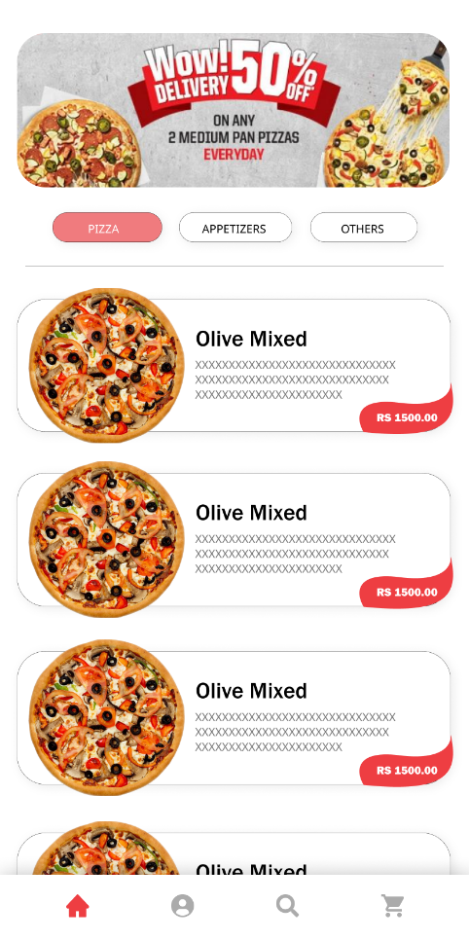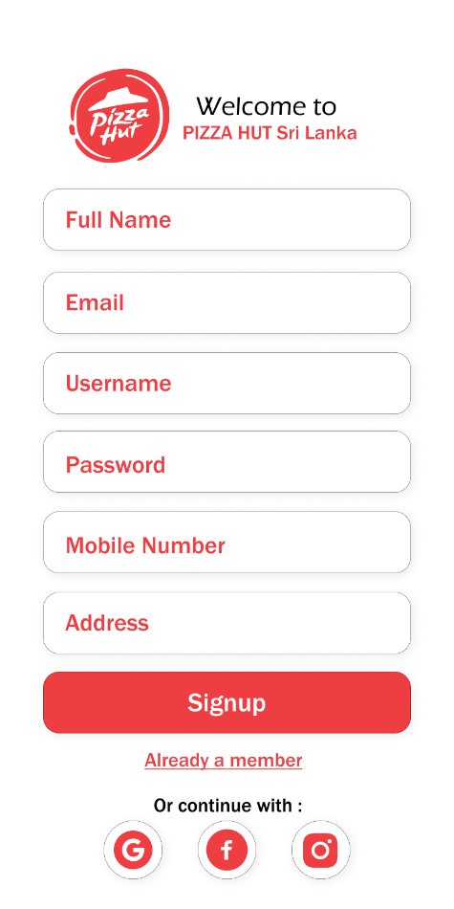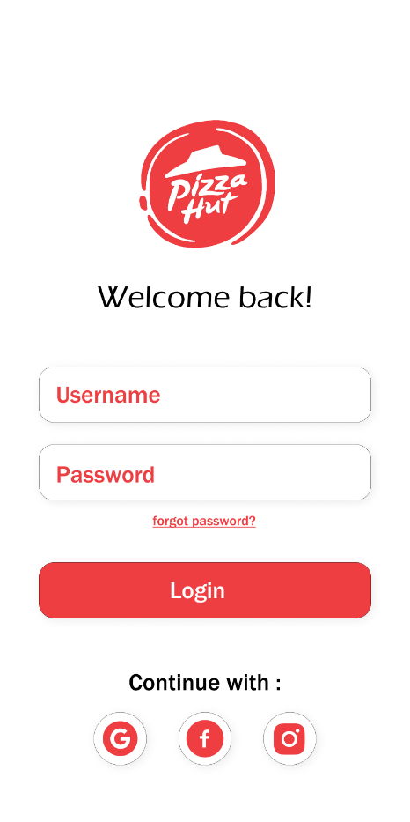

Figure 4: Main screen

Figure 3: Sign up

Figure 2: Login

Figure 1: Splash screen

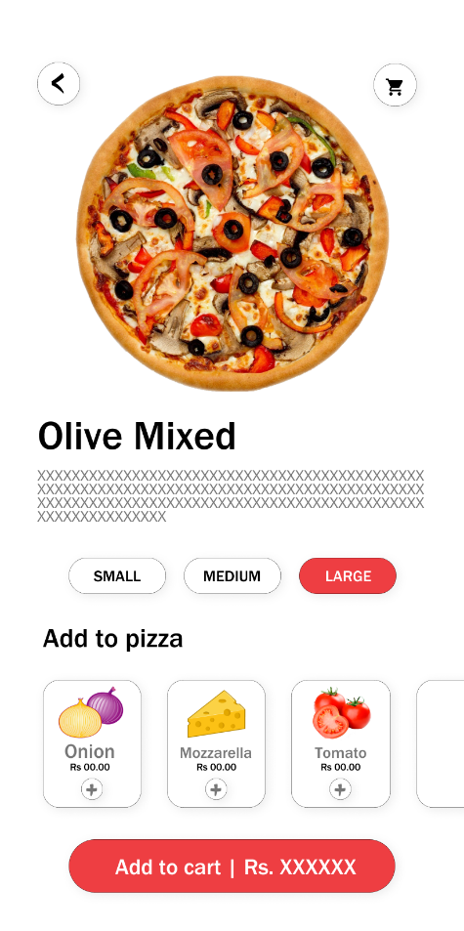

# 

Figure : Product card

Figure : Promotions

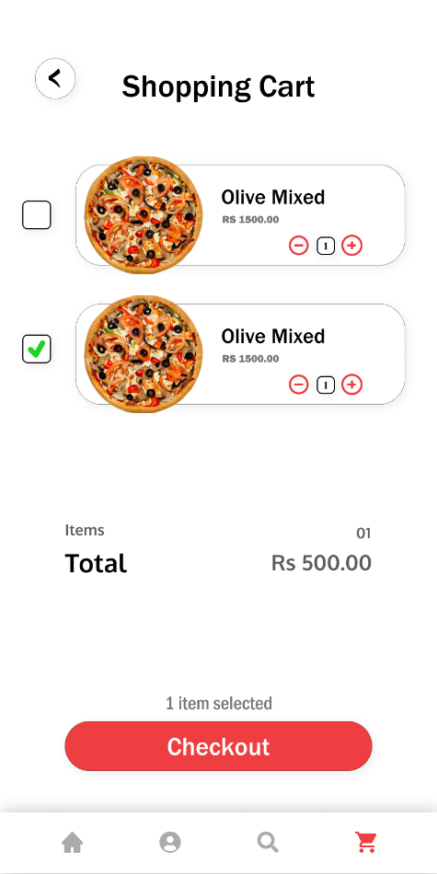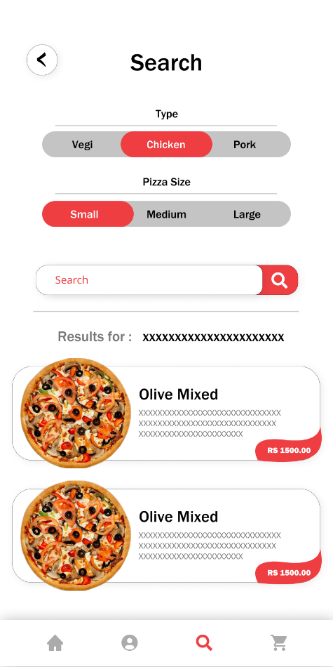

Figure : Shopping cart

Figure : Search

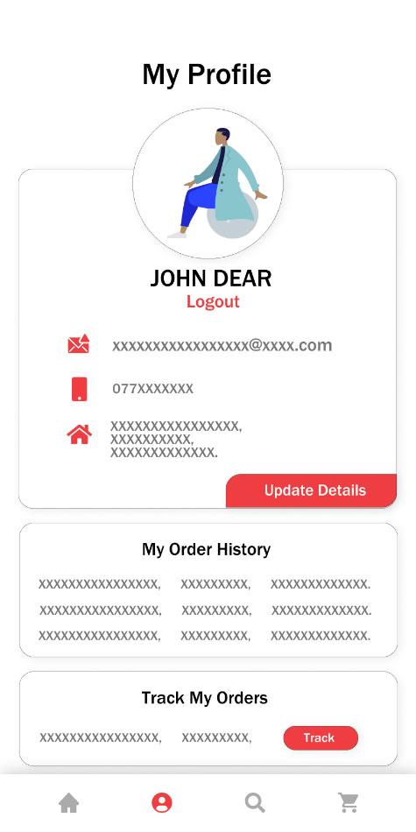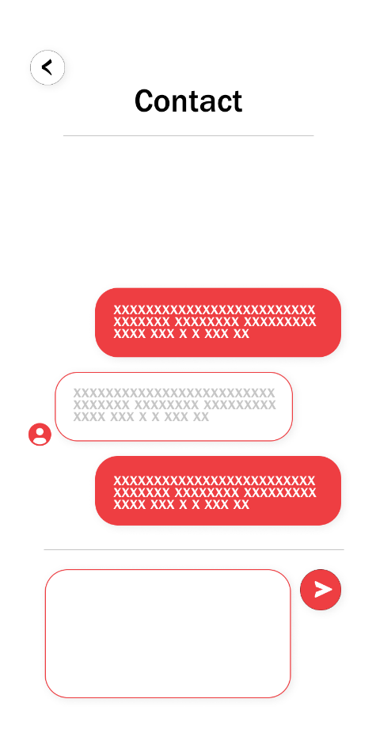

Figure : Profile

Figure : Contact

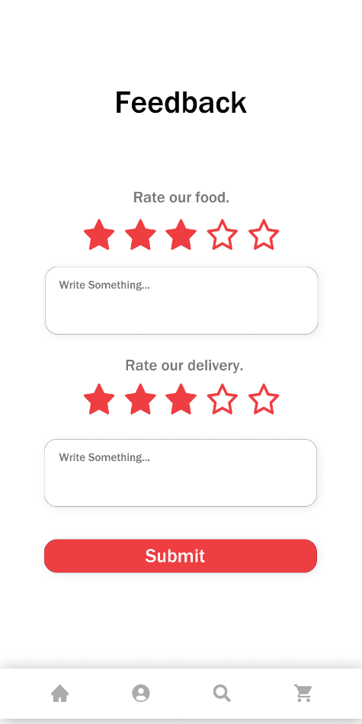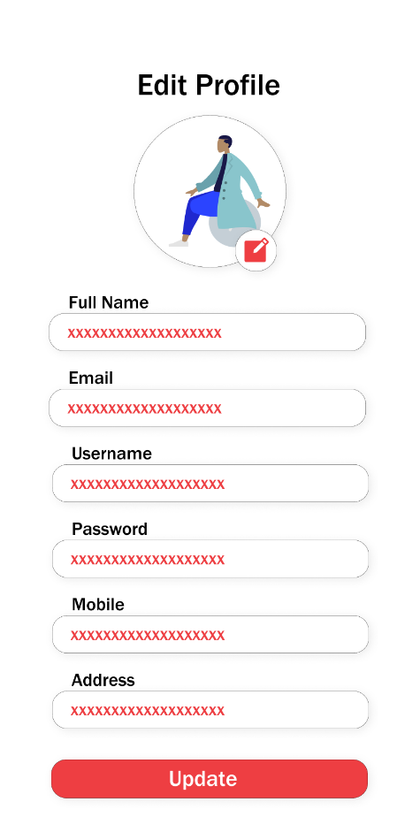

Figure : Edit profile

Figure : Feedback

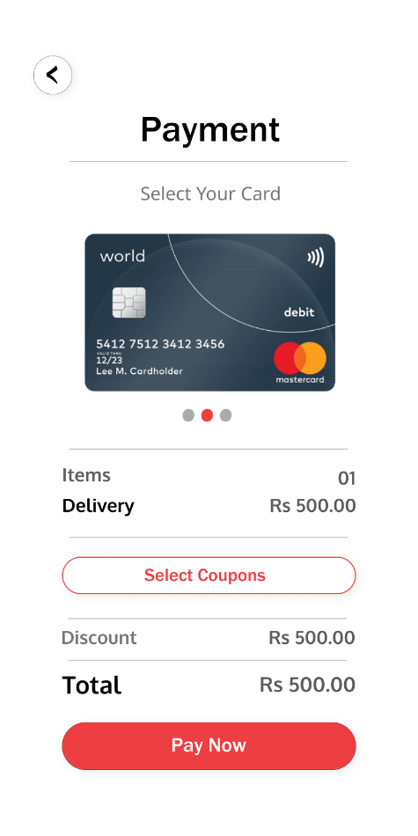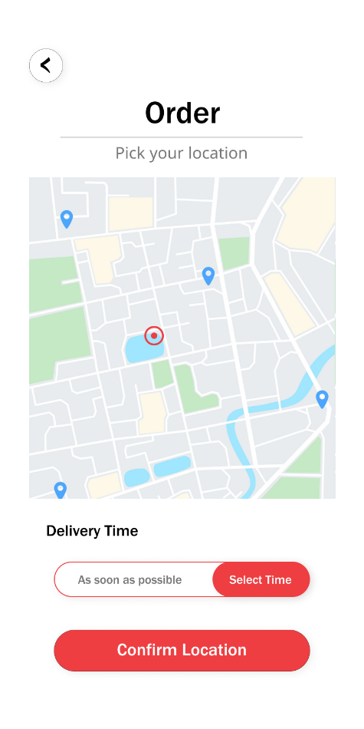

Figure : Payment

Figure : Order

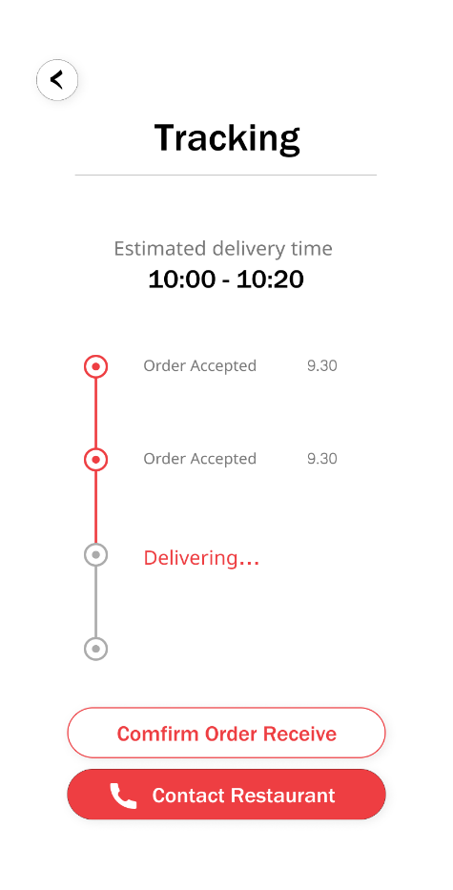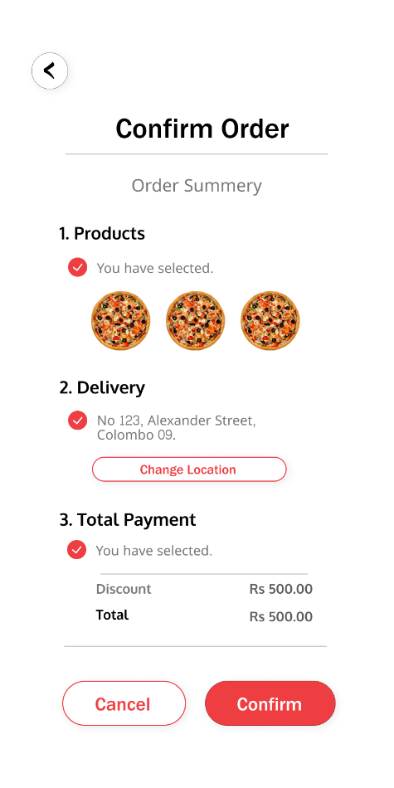

Figure : Tracking

Figure : Confirm order

# User Test Script

Product Area: Mobile Application (Pizza Hut SL)

User Type: Undergraduate

Duration: Approx. 15 minutes

Hi Jini, thank you again for taking your time to participate this 2nd interview regarding the usability testing of our mobile application.   
  
Before we begin, I’m going to give you a brief overview of the test and how it will work. And I hope you have already gone through the prototype we shared with you couple of days back.

This session is straightforward – I’ll be asking some of questions or tasks to do for in the prototype which are really simple and have one action.

It’s really important that we really want to get your honest opinion of how these features are implemented. What I meant from that is, we want to know how easy and reliable, that feature has implemented and what do you think of the way it is and the way it was. So, this time you may have the lead in the conversation rather than us.

So, lets move on with the interview. I hope you got the point here.  
  
If at any point you have questions, please don’t hesitate to ask. Do you have any questions so far?

Ok, Let’s get started.

First, just tell us what you thought about the overall design/implementation and what did you notice. I mean flaw points.

1. Welcome – Thanks – Introductions
2. Explanation of research team? Why we're testing our product.
3. Are you familiar with Pizza hut SL App?
4. Explain the session – how it will work (left side of this page)
5. Confirm time frame. Talk about sound, recording, etc.
6. Confirm the demographic information you have. This should be available from the screener.

**Moderator Notes**

The objectives of this session are to assess:

1. Overall user feedback of the implementation
2. User satisfaction

Measurements:

* Success rates
* Completion times
* Perceived ease of use

[Background information on goal.

*Example: we have already shared the version 1 of the prototype with her and, what we are looking in this section is, the overall thought of her about the implementations and to identify the design fault points that she may have noticed*

1: [Task 1]

First, just tell us what you thought about the overall design/implementation and what did you notice. I mean flaw points

[Background information on goal.

*Example: we have already shared the version 1 of the prototype with her and, what we are looking in this section is, the overall thought of her about the implementations and to identify the design fault points that she may have noticed*

[User has experience on the flow of the application because we already shared the prototype with her few days back.]

**Expected Actions:**

1. Navigate to different UIs in the application and identify flaw points

*Proceed to Task 2:*

This task addresses the overall feedback of the user about the implementation of features

This task has multiple touch points, and the user may easily forget to think aloud. If that occurs, encourage him/her to do so by saying:

1. Is that what you expected to see?
2. What did you see first? What caught your eye?
3. How do you compare this with the original one?

1: [Task 2]

Since you have gone through the prototype and have some sort of idea how this flow works, what did you think about the overall navigation methodologies that we have implemented so far? Because comparing to the actual product, the navigation is the major issue we noticed.

[User has experience on the flow of the application because we already shared the prototype with her few days back.]

**Expected Actions:**

1. Navigate to different UIs in the application

These tasks address the different navigation gestures implemented I the design.

1. Do you find it difficult to access the navigation buttons because of its positioning in the interface?
2. What user interfaces you may think should have most ease of access because you think, the users may access them very frequently than the others

6: Debriefing

Great! I think we are done with all of our question for you. I think we got quite clear picture on some of the ideas you mentioned during the testing process. So we hope to implement those in the application and roll out new design with them. So thank you Jini joining with us again.

User Type: Software Engineer

Duration: Approx. 10 minutes

Hi all, this is the second interview of the pizza hut Sri Lanka app re-designing user reviews.

Disal Peelapitiya is back with us, Hello Disal, welcome you again with this user review interview series.

Disal, as the suggestions gathered in the previous interview, we have designed a prototype for the re-designed pizza hut application. In designing that prototype your suggestions and thoughts were very helpful, and we have implemented them in our prototype.

The primary intention of this interview is to provide the opportunity to you to deal with the prototype and gather your suggestions and thoughts to further improve and fine-tune the product that we are going to implement in the future.

So, Disal we have sent you a link to access the prototype and we think you have gone through it several times and, now you have a proper understanding of it.

So, we like to know your thoughts about the design prototyped with comparing to the previous app and according to the suggestions that you have raised in the previous interviews.

Ok. Let’s move into the interview now.

First of all, I would like to ask have you gone through the prototype

That we have shared with you?

**Disal** : Yes. I have gone through it several times.

That’s great. So, we think now you are familiar with our prototype.

2: [Task 1]

Firstly, we would like to ask about your overall experience with the prototype. Are you think this product is going to resolve the issues that there were in the original application, or do you have any suggestions or opinions to further improve or fine tune the product?

[Background information on goal.

*Example: we have already shared the version 1 of the prototype with him and, what we are looking in this section is, the overall thought of him about the implementations and to identify the design fault points that he may have noticed*]

[User has experience on the flow of the application because we already shared the prototype with him few days back.]

**Expected Actions:**

1. Navigate to different UIs in the application and identify flaw points.
2. Try to use the different features of the prototype.
3. Explain the experience got by the user in interacting with the prototype.

*Proceed to Task 2:*

The intention of this task is to gather the user’s overall experience with the prototype compared to the previous application.

Other than the main intention it is also expected to test the user’s familiarity with the new navigation system through the app.

This task has multiple touch points, and the user may easily forget to think aloud. If that occurs, encourage him/her to do so by saying:

1. Is this the way you have suggested us in previous interview?
2. What is the better when it comparing to the previous app?
3. Do we need to any more features here to improve this page?

2: [Task 2]

Great, seems you have a good understanding of the prototype that we have implemented.

Now we would like to gather your suggestions about the new implementation of the menu page of the prototype. Since you have mentioned some issues about the previous application at the first review, we would like to invite you to have a closer look at the menu page and provide us more suggestions and thoughts if you have any?

[Background information on goal.

The user has raised more issues regarding this page in the first interview and provided more suggestions to us to improve the product by re-designing this page. Thus, we assume that he has a good understanding of this page, and he will be able to share more thoughts with us to improve our product regarding this page.]

[User has experience on the flow of the application because we already shared the prototype with him few days back.]

**Expected Actions:**

1. Navigate to different UIs in the application.
2. Compare prototype with previous application.

Debriefing

Perfect! That’s all for now. We think you have given us a good user review that enable us to improve our product more and provide a perfect product at the end. We appreciate your suggestions, and we hope to take your suggestions and opinions into our consideration in fine tuning this product. So, thanks again for sharing your valuable time with us and joining us.

This task mainly focusses on the menu page and to test the navigation experience that was experienced by the user.

1. Do you think the issues you mentioned in review 1 are resolved in here?

# Video Evidence

Video link: <https://web.microsoftstream.com/video/0d467812-5a81-449b-9fd4-13ca7908c1d1>

# Screenshots of the Prototype Version 02

Figure : Login Screen

Figure : Splash Screen

Figure 5: Product Screen

Figure 6: Search Screen

Figure 4: Main Screen

Figure 3: Signup Screen

Figure 10: Payment Screen

Figure 9: Location Screen

Figure 8: Edit Profile Screen

Figure 7: Profile Screen

Figure 14: Contact Screen

Figure 13: Track Order Screen

Figure 12: Order Summery Screen

Figure 11: Add a acard Screen

Figure 17: Feedback Screen

Figure 15: Coupon Add Screen

Figure 16: Promotions Screen

# Individual Contribution

|  |  |  |
| --- | --- | --- |
| **Registration No** | **Name** | **Contribution** |
| IT19188546 | Liyanage N.L.T.N. | * Version 1 prototype design * Version 2 prototype design * Wireframes and sketches for   + - Splash Screen     - Main Screen     - Search Screen     - Promotions Screen |
| IT19120812 | Liyanage M.L.A.P. | * + Wireframes Integration   + Sketches Integration   + Test script for user 1.   + Wireframes and sketches for     - Product page     - Shopping cart interface     - Contact us interface |
| IT19120362 | Thammita D.H.M.M.P | * Test Script for user 2. * Wireframes and Sketches for   + - Location choosing page     - Payment page.     - Order Summery page     - Order tracking page.     - Add cards page |
| IT19138114 | Hirimuthugoda U.J | * + Wireframes and sketches for     - Login page     - Registration page     - Feedback page     - Profile page     - Profile update page |